

Methods Unit 4 Test 4, 2018

(Calculator Free) Name__________________

Time: 22 minutes Marks: 22

1. [2, 2 marks]

Determine for each (you do not need to simplify):

1. y =

y = ln(2x - 1) – ln(3x + 1)

= -

🗸 for separating logs

🗸for correct derivative

1. y = x2. ln(sin x)

= 2x.ln(sin x) + x2()

🗸 for product rule

🗸 for correct derivative

2. [2, 2 marks]

Determine the following:

a)

= - ½

= - ½ ln|3 – 2x| + c

🗸 for rewriting

🗸 for correct integration

b) dx

½

= ½ ln |sin(2x)| + c

🗸 for rewriting

🗸 for correct integration

1. [4 marks]

Solve 2x – 1 = 33x, leaving your answer in exact form.

log 2x – 1 = log 33x

(x - 1) log 2 = (3x) log 3

x log 2 – log 2 = 3x log x

x log 2 – 3x log 3 = log 2

x(log 2 – 3 log 3) = log 2

x =

🗸 for log of both sides

🗸for rearranging

🗸 factorizing

🗸for solution

1. [3, 2 marks]

The continuous random variable X is defined by the p.d.f.

f(x) =

1. Determine the exact value of *q*.

= 1

= q (ln(3) – ln(1)) = 1

q =

🗸 for integral equal to 1

🗸integration

🗸 solution

1. Determine P(2 < x < 3)

dx = –

= 1 -

🗸 for integral

🗸 solution

5. [5 marks]

The diagram below shows y = loga(x), y = loga(x + b) and y = loga(x) + c.

Determine a, b and c.

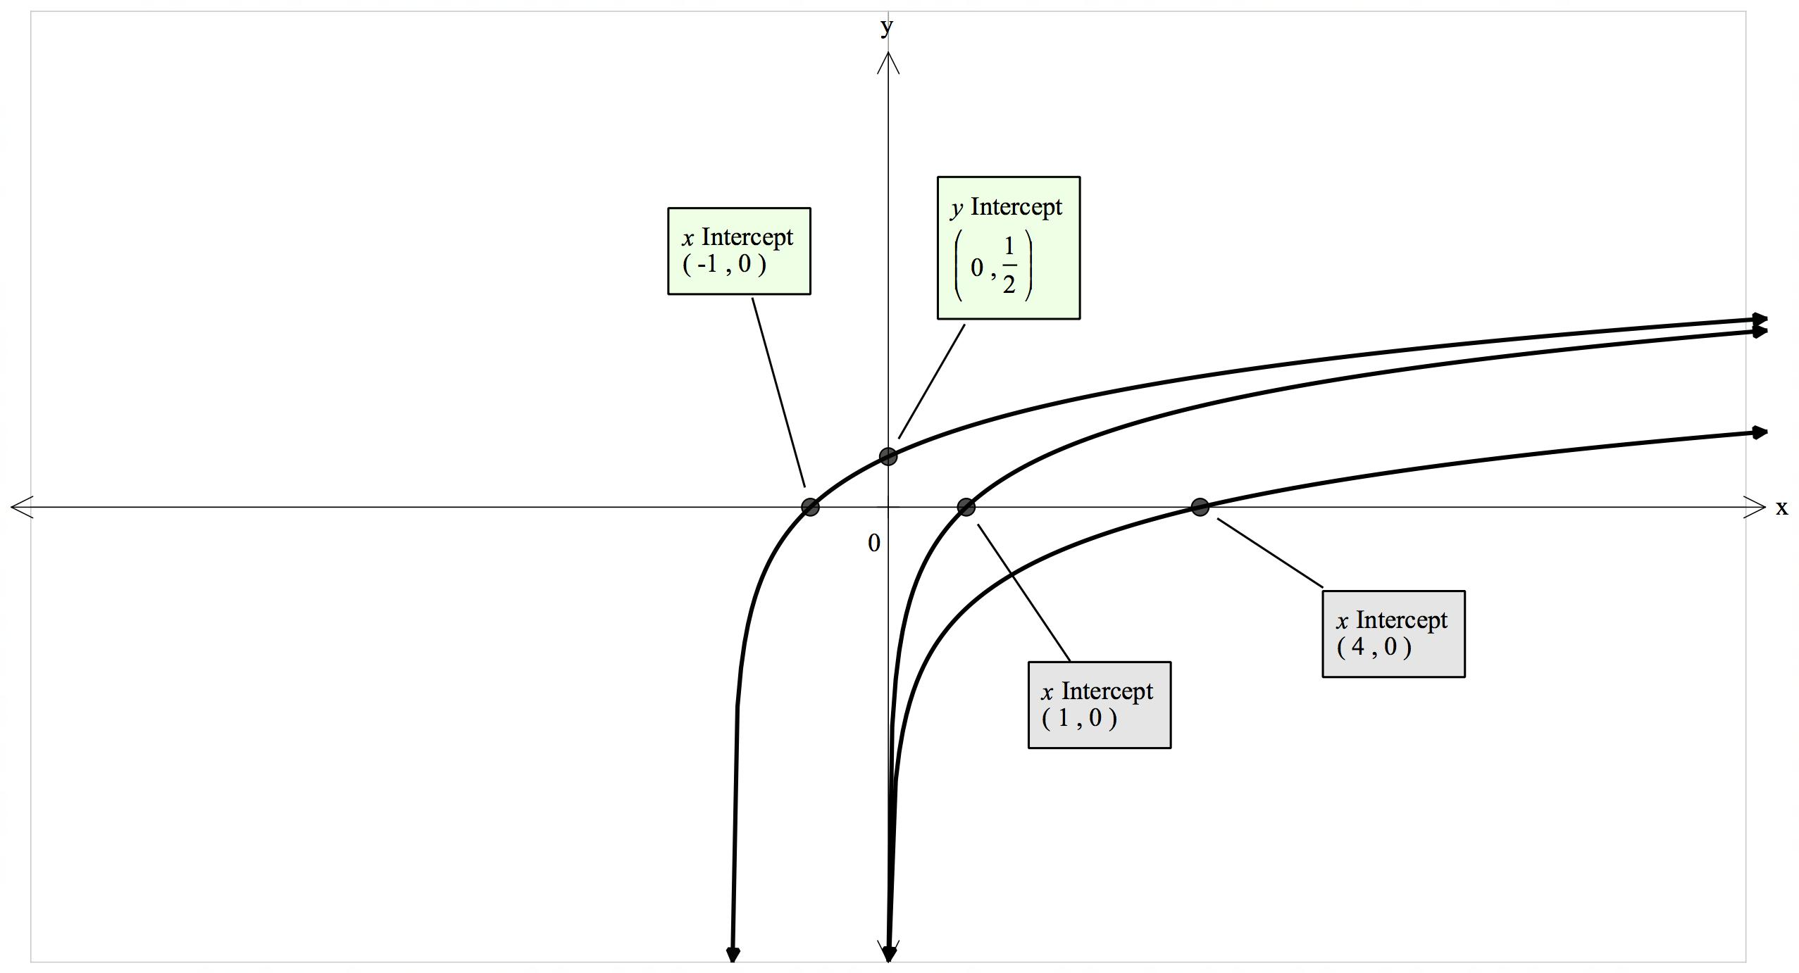

Translates 2 units to left so b = 2

loga2 = ½

= 2 a = 4

log44 + c = 0

c = -1

🗸 for b = 2

🗸for substituting (0, ½ )

🗸 for a = 4

🗸for substituting (4, 0)

🗸 for c = -1

 Methods Unit 4 Test 4, 2018

(Calculator Assumed) Name___________________

Time: 43 minutes Marks: 43

Show working in sufficient detail to support your answers. Incorrect answers given without supporting reasoning may not be allocated any marks.

6. [2, 3, 2, 2 marks]

The serving time, T seconds, for a customer at an ATM is a uniformly distributed random variable, where 50 T 150.

1. Sketch this distribution function below, using appropriate scales on each axis.

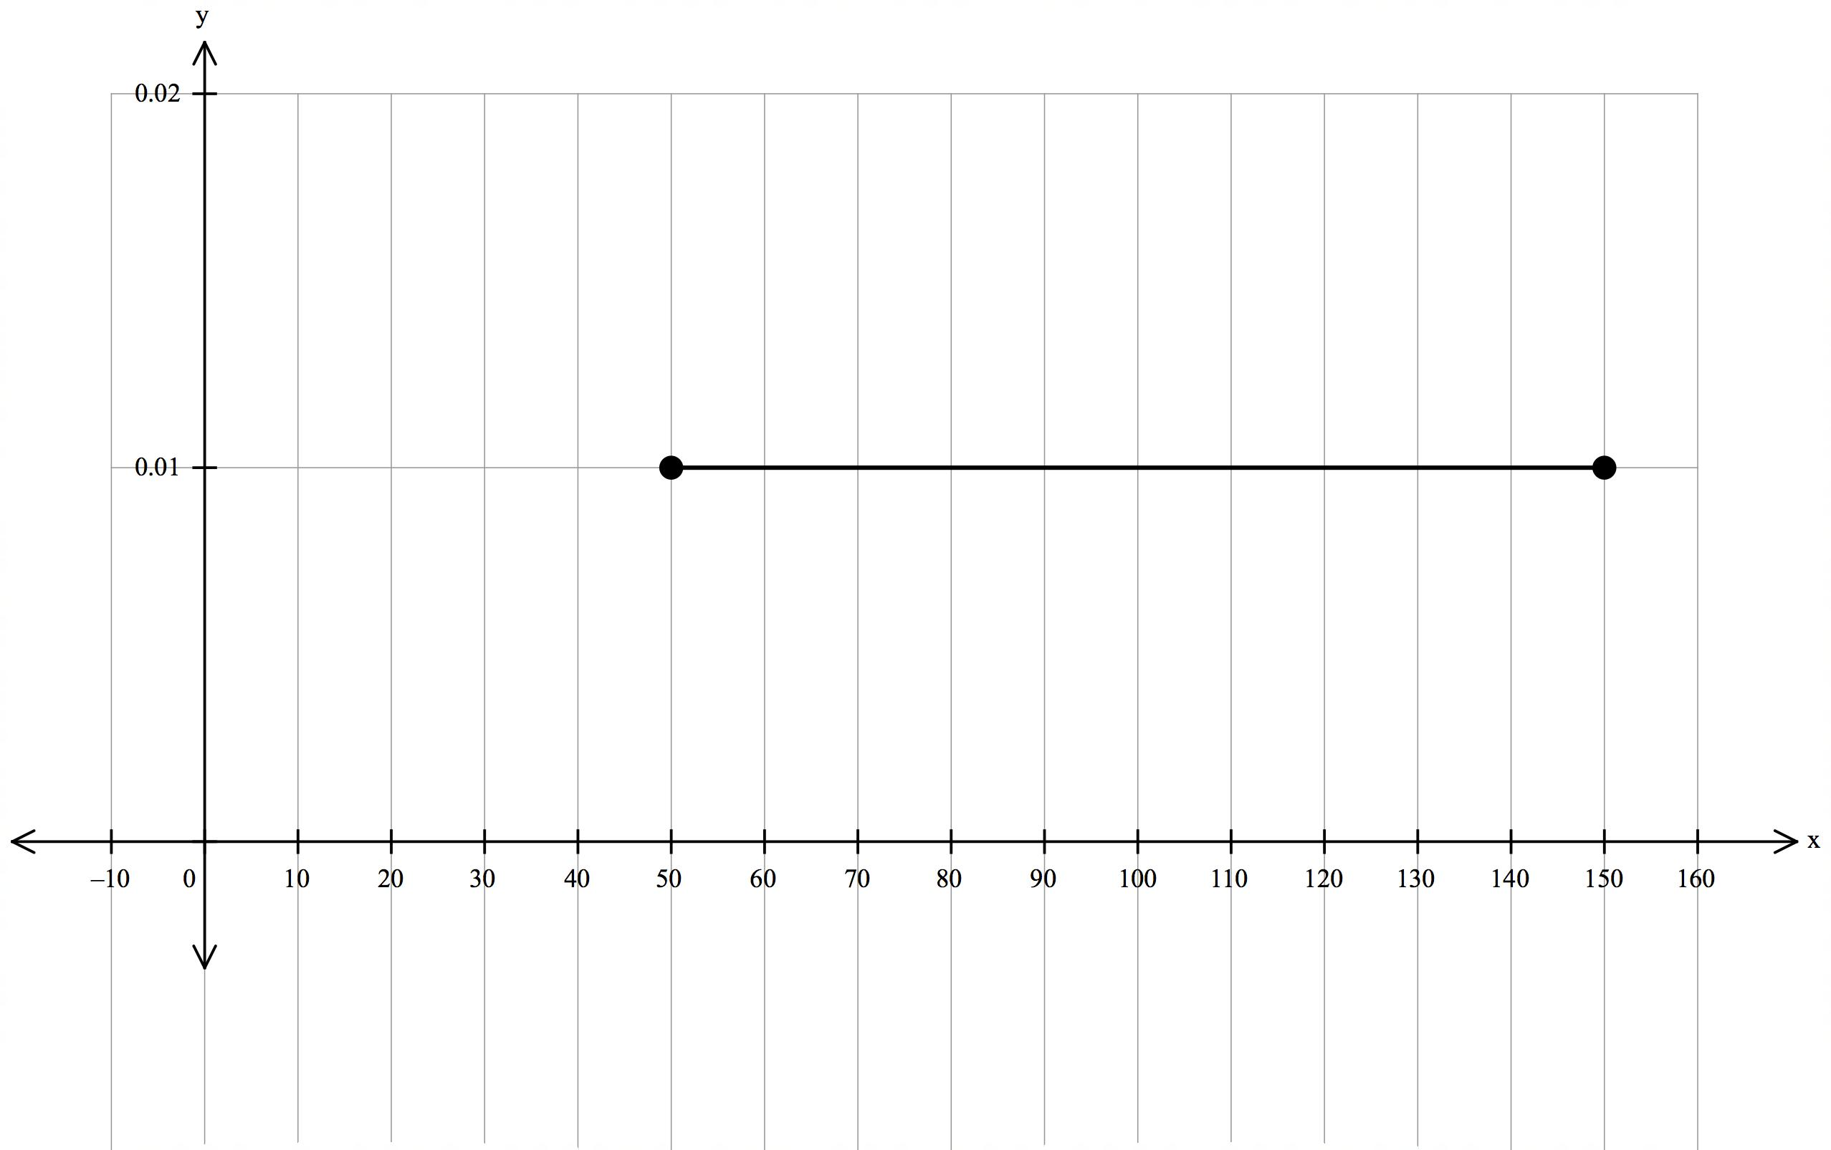

🗸 for k = 0.01

🗸uniform distribution 50

1. Find the expected value and standard deviation for this distribution.

E[X] = 100 sec

Var[X] =

= 833.33

SD[X] = 28.87

🗸 for E[X]

🗸for using integration to find variance

🗸for standard deviation

1. Evaluate P(T 100 | T 120)

= 0.286

🗸 for values of 0.2 & 0.7

🗸simplified answer

1. What is the probability that exactly 3 of the next 5 customers will require at least 2 minutes to be served?

Binomial distribution with n = 5 and p = 0.3

P(X = 3) = 0.1325

🗸 for correctly identifying binomial and the parameters

🗸 answer

7. [2, 3, 3, 3 marks]

The life (in years) of a light globe has a p.d.f. which can be modelled by:

f(x) =

1. Determine P(X < 1)

🗸 for correctly identifying definite integral

🗸 answer

1. Determine P(X < 3)

= 0.9959

🗸 for correctly identifying 2/3 +

🗸 remaining integral

🗸 answer

1. Determine the expected value for this distribution.

E[X] =

= 0.8889

🗸🗸 for correctly each part

🗸 answer

1. If you had 1000 globes, how many would you expect to last longer than 3 years?

1 – 0.9959 = 0.0041 from part b

0.0041 x 1000 = 4 globes

🗸🗸 for correct probability

🗸 answer as whole number

8. [2, 2, 4 marks]

1. Consider the shaded area shown between the graph of y = ex, the y-axis and y = 2.

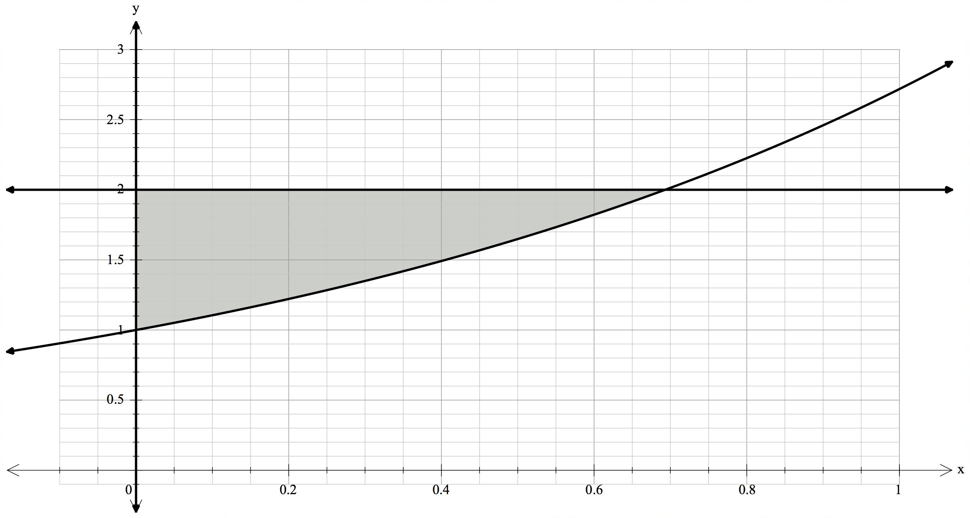

**A**

1. Determine the exact coordinates of point A.

ex = 2

x = ln 2 (ln 2, 2)

🗸🗸 for exact value of x

🗸 answer as a coordinate

1. Hence, or otherwise, determine the shaded area.

= 2 ln(2) – 1 [or 0.386]

🗸🗸 integral

🗸 answer

1. If the area between y = ex, the x-axis, the y-axis and x = *k*, where k > 0, is to be equal to 2 square units, determine the exact value of *k*.

dx = 2

[ex] = 2

ek – 1 = 2

ek = 3

k = ln 3

🗸 for integral

🗸for integration

🗸for equation

🗸 for value of k

9. [1, 4 marks]

1. Determine f ‘(x), given f(x) =

=

🗸🗸 for correct derivative

1. Hence, or otherwise, show that = )

dx = dx

= -

= - ½ ln(2)

= )

🗸 for use of part a)

🗸for integrations

🗸 substitution

🗸showing result is as shown

10. [3, 1, 2, 2, 2 marks]

A continuous random variable X has a pdf such that f(x) = 0.4e-0.4x defined over interval [0,

a) Show that P(X k) = 1 – e-0.4k

P(X k) =

= [-e-0.4x]

= e-0.4k + 1 or 1 - e-0.4k

🗸 for use of integral

🗸for integration

🗸showing result is as shown

Hence or otherwise determine:

b) P(X 5)

1 – e-2 = 0.8647

🗸 for use of part a)

c) P(5 X 6)

0.9093 – 0.8647 = 0.0446

🗸 for correct values

🗸 for correct answer

c) P(X 6 | X 5)

= 0.3296

🗸 for correct values

🗸 for correct answer

d) the value of a, given that P(X a) = 0.2

1 – e-0.4a = 0.2

Thus a = 0.56

🗸 for correct use of part a

🗸 for value of a